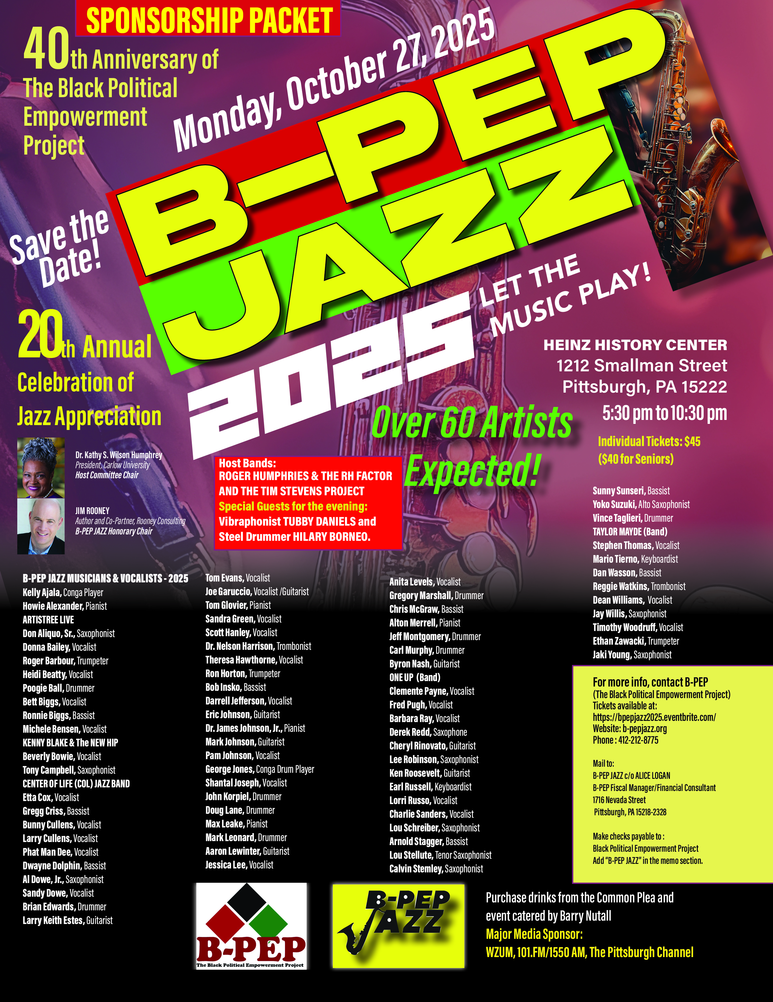
The Black Political Empowerment Project

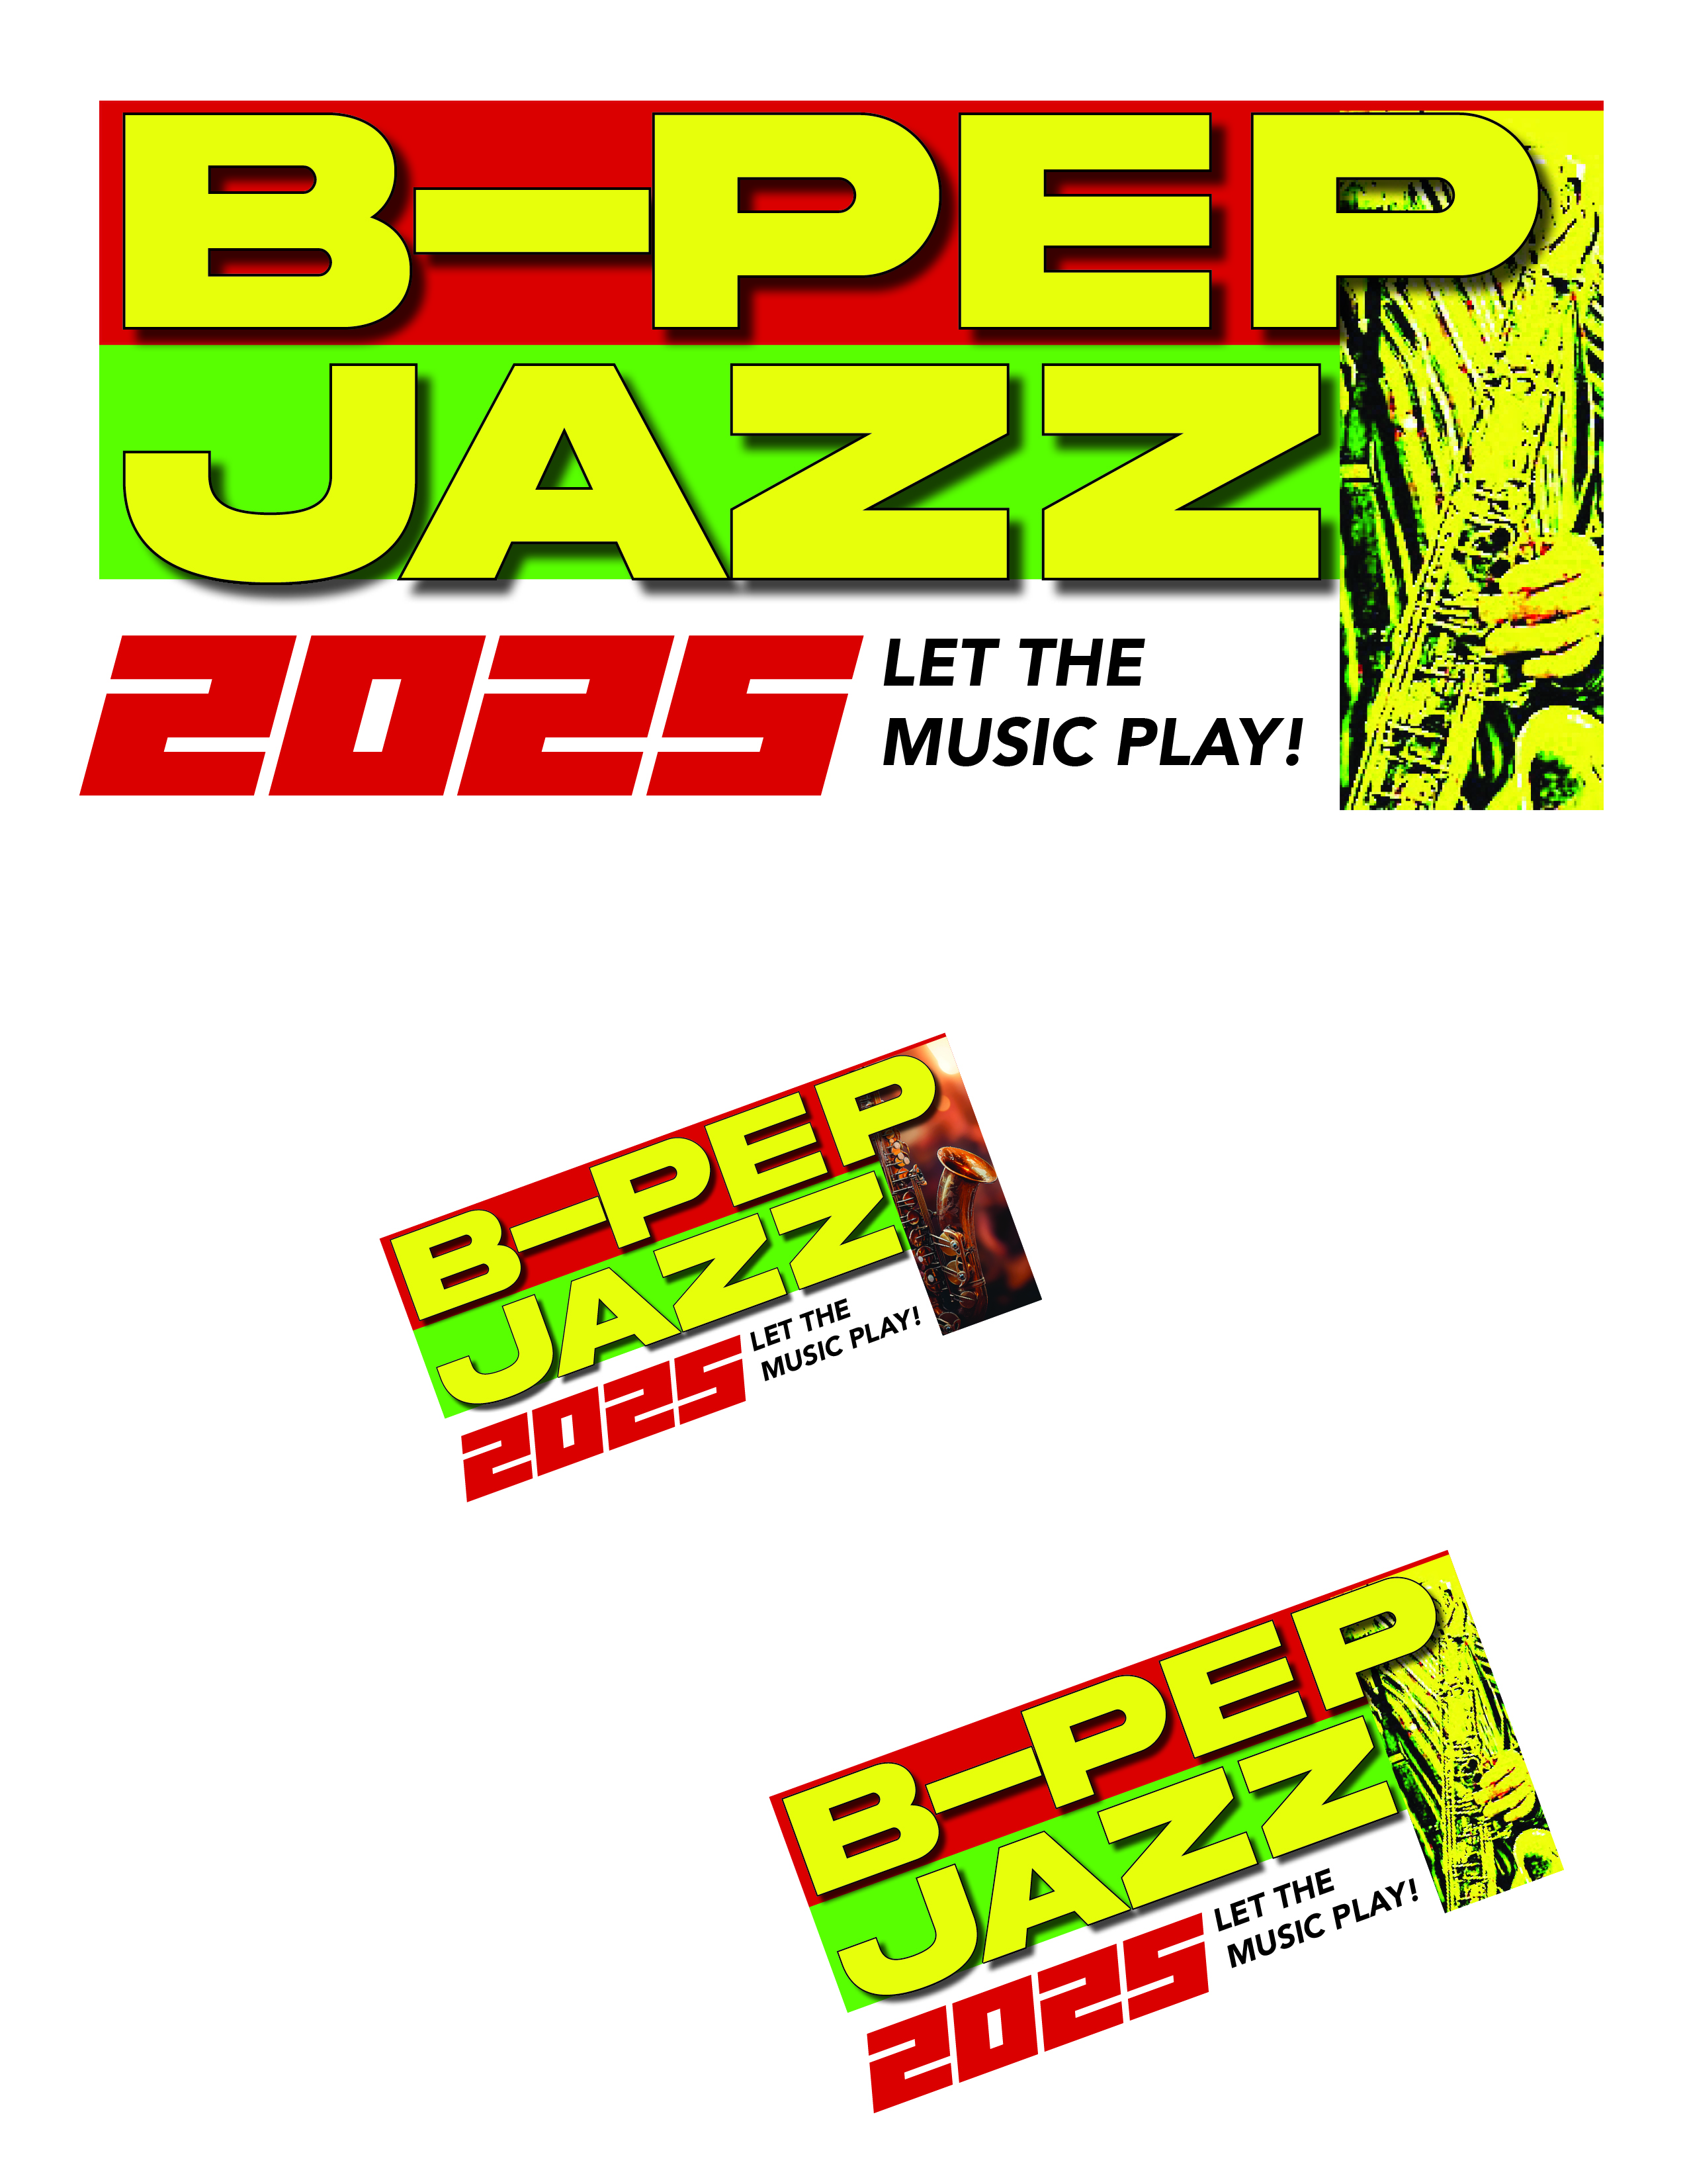

Signature Event
Since 2006, to raise awareness of the organization and its programs, the Black Political Empowerment Project has hosted B-PEP JAZZ, a five-hour jazz marathon which raises funds to help defray the cost of the many fine programs that are offered to the Pittsburgh Region.

20th Annual B-PEP JAZZ
Celebrating the 40th Anniversary of B-PEP!

A musical ‘fun-raiser’ celebrating
The Black Political Empowerment Project’s
40 years of serving the Metropolitan Pittsburgh community
Monday, October 27, 2025
Heinz History Center
1212 Smallman Street
Pittsburgh, PA 15222
5:30 p.m. — 10:30 p.m.





The Black Political Empowerment Project

B-PEP JAZZ 2025 AWARDEES:
A Special Tribute to Former Jazz Club Owners
Who Kept Jazz alive in Pittsburgh:

Tom Burley, Crawford Grill on the Square
Al Dowe, “Dowe’s on Ninth”
Arthur Jim Barthrop, The Pyramid Restaurant and Lounge
Gene Jeter, Too Sweet Lounge
Muzz Meyers, The Balcony
Caren and Don Miller, CJ’s
Craig Poole, James Street
Tim Guthrie & Justin Strong, Shadow Lounge & Ava

A Special Tribute to Two Women who have been Instrumental and COMMITTED to Presenting HARAMBEE FESTIVALS
in the Pittsburgh Region for many years:

Anita Drummund, Festival Director
Pearlina Story, Festival Director

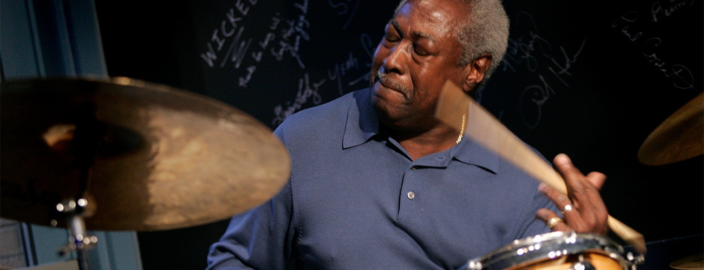

The Black Political Empowerment Project

IN MEMORIAM B-PEP JAZZ 2025:

Maurice “Ricky’ Brooks, Guitarist
Marc Custer, Trumpeter
Magumba Lowery, Conga Player
Willie Parham, Flutist
Chuck Spatafore, Drummer
Nancy Taylor, Pianist

HOST BANDS
ROGER HUMPHRIES & THE RH FACTOR

Dwayne Dolphin, Bassist
Roger Humphries, Drummer
Max Leake, Pianist
Lou Stellute, Tenor Saxophonist
Yoko Suzuki, Alto Saxophonist

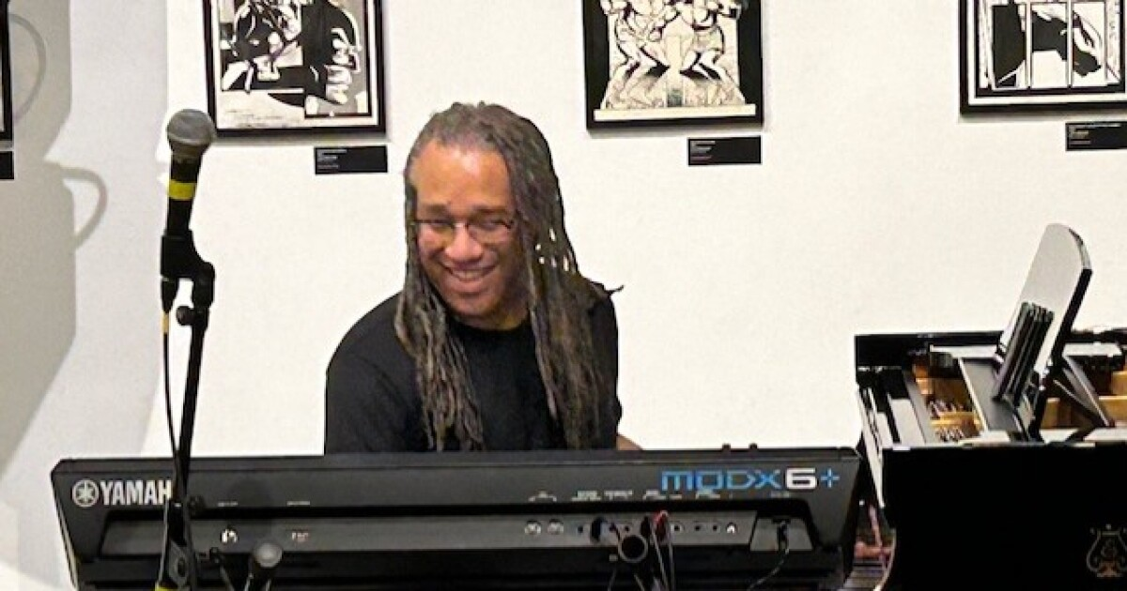

The TIM STEVENS PROJECT
Howie Alexanader, Pianist
Kenny Blake, Saxophonist
Eric Johnson, Guitarist
Tim Stevens, Vocalist
Vince Taglieri, Drummer
Dan Wasson, Bassist

SPECIAL MUSICAL GUESTS FOR THE EVENING:
Tubby Daniels, Vibraphonist
Hilary Borneo, Steel Drummer
The Black Political Empowerment Project

B-PEP JAZZ GUEST EMCEES:

Kiki Brown, WAMO, 107.3 FM
Scott Hanley, WZUM, 101.1 FM/1550 AM, The Pittsburgh Jazz Channel
Bill Hillgrove – The Voice of the University of Pittsburgh Pitt Panthers, former Voice of the Pittsburgh Steelers
Mikey Hood – KDKA TV/ KDKA PLUS
Chuck Leavens, WZUM, 101.1 FM/The Pittsburgh Jazz Channel
Bill Neal, The New Pittsburgh Courier
Lisa Smith, Host, “Intersections”, KDKA TV PLUS
Andrew Stockey, WTAE TV
Bob Studebaker, WESA FM, Essential Public Radio, 90.5 FM

B-PEP Jazz Host Committee Chair, Dr. KATHY S.WILSON HUMPHREY, President Carlow University
B-PEP JAZZ Honorary Chair: JIM ROONEY, Author and Co-Partner, Rooney Consulting

B-PEP JAZZ HOST COMMITTEE:
Jared Bachar, President & CEO, Visit Pittsburgh
Arthur L. & The Hon. Cynthia A. Baldwin
Kenya T. Boswell, Sr. Vice President of Community Affairs, Highmark Health
Dr. Quintin B. Bullock, President, Community College of Allegheny County
Janis Burley, President and CEO August Wilson African American Cultural Center
Esther L. Bush, Interim President & CEO, Urban League of Greater Pittsburgh
Annie Hanna Cestra, COO, Hanna Real Estate
Daylon A. Davis, Past President, NAACP Pittsburgh Branch
Jackie Dixon, Member, Regional Asset Board (RAD)
Rod Doss, Editor & Publisher, New Pittsburgh Courier
Dr. Edmund Effort, Dentist
Cecelia Trower Epperson
Bill Flanagan, Host, WPXI’s “Our Region’s Business”, Special Advisor, Alleg. Conference
Evan Frazier, President & CEO, The Advanced Leadership Institute (TALI)
Dr. Leon Haley, Former Dean, Graduate School of Public & International Affairs, Pitt
Peggy Harris, President & CEO, Three Rivers Youth
Dr. Rahmon Hart, Director of Community Relations, Rivers Casino
Kevin L. Jenkins, President & CEO, Manchester Bidwell Corporation
Jason Jones, Director Vice President, Community Development, Dollar Bank
Sean Jones, International Trumpeter
Dr. Linda S. Lane, Former Superintendent, Pittsburgh Public Schools
Katharine Eagan Kelleman, CEO, Port Authority of Allegheny County
Claudette Lewis
Mark Lewis, President & CEO, the POISE Foundation
Hon. Timothy K. Lewis, former U.S. District Judge
Monica I. Malik, Vice President Public Affairs Market Manager,
W. PA., Citizens Bank
Marimba Milliones, President & CEO, Hill District Community Development Corp..
Carol Neyland, Former Sr. Vice President Community Development, Dollar Bank
Jeff Nobers, Executive Director, Builders Guild of W. PA
Dan Onorato, Executive Vice President, Corporate Affairs, Highmark Health
K. Chase Patterson, Director, Urban Academy
Clyde Wilson Pickett, Vice Chancilor for Institutional Engagement and Well Being
Ronald D. Porter, RDP Consulting Service
The Black Political Empowerment Project

Angela Reynolds, President, YWCA of Greater Pittsburgh
A. Odell Richardson, Treasurer, Black Political Empowerment Project
Hon. Valerie McDonald Roberts, Former Pittsburgh City Councilwoman
William “Jack” Simmons, Esq., Former Director, Shuman Juvenile Detention Center
Greg Spencer, Managing Director, Spencer MacCleary & Associates LLC
Dr. Marcia Sturdivant, President & CEO, NEED
Dr. James E. Taylor, Chief Diversity, Inclusion & Education Officer, UPMC
J.T. Thomas, Steelers Super Bowl Champion #24
Nancy Washington, Allegheny Housing Rehabilitation Corporation (AHRCO)
Joy Maxberry Woodruff, Director, Pittsburgh “Do the Write Thing”



The Black Political Empowerment Project

Corporate Sponsorship Levels

SUPER HIGH NOTE SPONSOR
As a High Note Sponsor You Will Receive:
• A full page (5”x8”) Color Ad back cover
B-PEP JAZZ program booklet
• Twenty (30) tickets to the event
• Listing in the Program as a Super High Note Sponsor
• Dedicated reserved seating at the event
• Name/Logo visibility at the event
• Live mentions at the event
• Other promotional considerations
(Please email all advertisement information to bpepjazz@gmail.com by Friday, October 3, 2025.)
Investment: $20,000

HIGH NOTE SPONSOR
As a High Note Sponsor You Will Receive:
• A full page (5”x8”) Color Ad inside front cover and across the first page of the
B-PEP JAZZ program booklet
• Twenty (20) tickets to the event
• Listing in the Program as a High Note Sponsor
• Dedicated reserved seating at the event
• Name/Logo visibility at the event
• Live mentions at the event
• Other promotional considerations
(Please email all advertisement information to bpepjazz@gmail.com by Friday, October 3, 2025.)
Investment: $15,000
_______________________________________________________________________________________________________________________________________________________________________________

KEY SIGNATURE SPONSOR
As a Key Signature Sponsor You Will Receive:

• A full page (5”x8”) Color Ad inside back cover OR outside back cover of the B-PEP
JAZZ program booklet
• Fifteen (15) tickets to the event
• Listing in the program as a Key Signature Sponsor
• Dedicated reserved seating at the event
• Name/Logo visibility at the event
• Live mentions at the event
• Other promotional considerations
(Please email all advertisement information to bpepjazz@gmail.com by Friday, October 3, 2025.)

Investment: $10,000
_______________________________________________________________________________________________________________________________________________________________________________

The Black Political Empowerment Project

SHARP KEY SPONSOR
As a Sharp Key Sponsor You Will Receive:
• A full page (5”x8”) Color Ad premium placement in the
B-PEP JAZZ program booklet
• Twelve (12) tickets to the event
• Listing in the Program as a Sharp Key Sponsor
• Dedicated reserved seating at the event
• Name/Logo visibility at the event
• Live mentions at the event
• Other promotional considerations
(Please email all advertisement information to bpepjazz@gmail.com by Friday, October 3, 2025.)
Investment: $7,500
______________________________________________________________________________________________________________________________________________________________________________

MAJOR KEY SPONSOR
As a Major Key Sponsor You Will Receive:

A full page (5”x8”) Color Ad premium placement in the B-PEP JAZZ program booklet
Ten (10) tickets to the event
Listing in the Program as a Major Key Sponsor
Dedicated reserved seating at the event
Name/Logo visibility at the event
Live mentions at the event
Other promotional considerations
(Please email all advertisement information to bpepjazz@gmail.com by Friday, October 3, 2025.)

Investment: $5,000
_______________________________________________________________________________________________________________________________________________________________________________

KEY NOTE SPONSOR
As a Key Note Sponsor You Will Receive:

A full page (5’x8’) black & white ad in the B-PEP JAZZ Program Booklet
Logo visibility at the event
Eight (8) tickets to the event
Live Mentions at the event
Listing as Key Note Sponsor in Program Booklet
(Please email all advertisement information to bpepjazz@gmail.com by Friday, October 3, 2025.)

Investment: $3,000
_______________________________________________________________________________________________________________________________________________________________________________

CLEF NOTE SPONSOR
As a Clef Note Sponsor You Will Receive:

A ½ page (5”x3.5”) black & white ad in the B-PEP JAZZ Program Booklet
Six (6) tickets to the event
Live mentions at the event

Listing as Clef Note Sponsor in Program Booklet
(Please email all advertisement information to bpepjazz@gmail.com Friday, October 3, 2025)
Investment: $1000

The Black Political Empowerment Project

Individual & Community
Agency Contributions

B-PEP GOLD

• Six (6) tickets and inclusion of organization’s name in program booklet

Investment: $750.00-$999.00

B-PEP SILVER

As a B-PEP Silver You Will Receive:

• Four (4) tickets and inclusion of organization’s name in program booklet

Investment: $500.00-$749.00

B-PEP BRONZE

As a B-PEP Bronze You Will Receive:

• Two (2) tickets and inclusion of organization’s name in program booklet
Investment: $250.00-$499.00

Individual Donations

The names of those who contribute from $100.00—$249.00 will be acknowledged in the “Friends of B-PEP" section of the program booklet, and will receive one ticket.

All contributions must be received by Friday, October 3, 2025 to ensure
a listing in the program.
Donations under $100.00 are welcomed but will not be acknowledged in the printed program.

The Black Political Empowerment Project

B-PEP Sponsorship Form (INVOICE)

Corporate Sponsorship
COMPANY NAME: _______________________________________________________________
ADDRESS: ______________________________________________________________________
CITY: _______________________________________ STATE:________________ ZIP:________
CONTACT: ______________________________________________________________________
TITLE:__________________________________________________________________________
WORK PHONE: ____________________________ ALT PHONE: _________________________
FAX NUMBER: ___________________ EMAIL: _______________________________________

SPONSORSHIP (SELECT ONE) Get a full page ad in the (CEIR) program for an additional $500
____ Super High Note Sponsor: $20,000 ____ Plus $500 (CEIR) ad ____ Total $20,500
____ High Note Sponsor: $15,000 ____ Plus $500 (CEIR) ad ____ Total $15,500
____ Key Signature Sponsor: $10,000 ____ Plus $500 (CEIR) ad ____ Total $10,500
____ Sharp Key Sponsor: $7,500 ____ Plus $500 (CEIR) ad ____ Total $8,000
____ Major Key Sponsor: $5000 ____ Plus $500 (CEIR) ad ____ Total $5,500
____ Key Note Sponsor: $3000 ____ Plus $500 (CEIR) ad ____ Total $3,500
____ Clef Note Sponsor: $1,000 ____ Plus $500 (CEIR) ad ____ Total $1,500

___________________________________________________________________________________

Community Organization/Agency Sponsorship

SPONSORSHIP (SELECT ONE)
____ B-PEP Gold: $750.00-$999.00
____ B-PEP Silver: $500.00-$749.00
____ B-PEP Bronze: $250.00-$499.00
__________________________________________________________________________________

Individual Donation
____ Friends of B-PEP $100.00 - $249.00
____ Other Donation Amount
____ Check Enclosed

Please make your check payable to: BLACK POLITICAL EMPOWERMENT PROJECT
in the Memo line please indicate “B-PEP JAZZ.”

Email all advertisement information to bpepjazz@gmail.com by Friday, October 3, 2025
We encourage advertisers to send in their ads and donations as soon as possible!
For additional information please call 412.758.7898 or 412.361.2736

Please mail check to:
Black Political Empowerment Project c/o Alice Logan, B-PEP Fiscal Manager/Financial Consultant,
1716 Nevada Street, Pittsburgh, PA 15218-2328

PAYPAL is also available for payment.

ALL TICKETS WILL BE AVAILABLE AT THE “WILL CALL” TABLE THE EVENING OF THE EVENT
____ THIS IS A CONTRIBUTION. PLEASE DONATE MY/OUR TICKETS.

The Black Political Empowerment Project

About Us - Celebrating 40 Years!

The Black Political Empowerment Project (B-PEP) was launched on May 21, 1986 as a non-partisan community collaborative consisting of individuals and agency, organization and religious leaders committed to building political power and influence for the African American community by:

- Advocating that All African Americans are registered to vote and “VOTE in EACH and EVERY election!”
- Advocating that those in political office expeditiously and effectively meet the needs, aspirations, and concerns of African Americans.
- Promoting the goal of realizing the FULL political power of the BLACK vote.

B-PEP relies on the dedication of devoted people who donate an incredible number of hours to uplift our communities by providing hope and a sense of purpose.

“Human progress is neither automatic nor inevitable...Every step toward the goal of justice requires sacrifice, suffering, and struggle; the tireless exertions and passionate concern of dedicated individuals.” -Martin Luther King Jr.

••••••••••••••••••••••••••••••••••••••••••••••••••••••••••••••••••••
VISION
To empower the Black vote, increase civic engagement, support Black families, create safer communities, and expand job, economic, and entrepreneurial opportunities for long-term community sustainability.

MISSION
The Black Political Empowerment Project (B-PEP) and it’s initiatives, the Greater Pittsburgh Coalition Against Violence (CAV), and the Corporate Equity and Inclusion Roundtable (CIR), work collectively to empower the Black community through family and political engagement, identifying systemic barriers, and fostering both short- and long-term solutions to enhance community well-being and create meaningful economic opportunities.

The Black Political Empowerment Project

OUR PROJECTS – Making a Difference in the Pittsburgh Region

The GREATER PITTSBURGH COALITION AGAINST VIOLENCE (CAV) was launched by
B-PEP and One Hood on February 8, 2007, galvanized by research that reported Pennsylvania as leading the nation in homicide rates of African Americans. Following the first year of existence the Coalition continued under the leadership of B-PEP. It is an inter-racial, inter-generational initiative of community and religious leaders, police, educational and governmental representatives, and concerned citizens from throughout the Pittsburgh Region.

CAV’s work is aimed at the development, expansion, implementation and sharing of the Black Political Empowerment Project’s “Strategies for Change: Creating More Peaceful Communities” document. The third edition contains some thirty-eight sections, with a total of over 800 anti-violence strategies, which B-PEP/CAV representatives attempt to share, ongoingly, with various community partners. Our Youth Summits are structured to allow for sections to be selected by youth, with assistance from school staff members, for use in our anti-violence Youth Summits, both within the School District of Pittsburgh, and in various school districts located outside of the city of Pittsburgh as well. When possible we schedule follow-up youth-led conversations and activities in each school to continue the conversation of implementation of our CAV anti-violence strategies. Our goal is to reach more students, more school districts, and more partners so as to positively impact the schools, the families and their surrounding communities in lessening the violence being experienced by far too many people. We are now seeking more community-based organizations, agencies and church groups to adopt, embrace and implement specific sections of our CAV document. We also host Community Peace Summits in various neighborhoods aimed at reaching adults as well as young people. In recent months B-PEP/CAV staff members developed a sharing curriculum for each section of the “Strategies for Change” document which will contribute to more powerful and interactive Peace Summits.

The National Urban League President, Marc Morial, called our “Strategies for Change” document, upon which our work is built, one of the most comprehensive anti-violence documents in the nation! Previous Pittsburgh Urban League President, Esther L. Bush, sent our CAV document out to all Urban League affiliates across the nation! Since the release of the original in 2008, CAV has released updated versions with added sections such as anti-bullying, social media/internet safety strategies, violence against women and the LGBTQAI community, and has also published a Community Services Directory as a service to those impacted by violence. The fourth edition of the Directory was published in 2025. Late in 2018 the Community College of Allegheny County (CCAC) created a model of implementation of CAV strategies, which could be adopted and utilized by area colleges and universities.

Over the years, with the financial partnerships of entities such as the Pittsburgh Foundation, the Jewish Federation of Greater Pittsburgh, Vibrant Pittsburgh, Highmark Blue Cross Blue Shield, Dollar Bank, Jones Day, PNC Financial, UPMC, and more recently the McAuley Foundation and the Opportunity Fund at the POISE Foundation this B-PEP initiated project has been able to continue to exist and to expand its influence throughout the Pittsburgh Region, and beyond.

CIVIC ENGAGEMENT Through our partnership with the Nonprofit Voter Engagement Network, B-PEP’s Civic Engagement work focuses on non-partisan voter registration, mobilization, voting protection and voter education. The goal is to urge those who feel un-empowered to commit to voting in “Each and Every Election”, and by doing so to help meet the needs, aspirations, and concerns of the community by engaging with local and regional political leaders, and to ongoingly help make the voting process more accessible to all. B-PEP was an early partner to the statewide “Fair Districts PA” initiative which continues to help ensure that voting districts are drawn in a reasonable and non-partisan fashion across the Commonwealth of Pennsylvania, aimed at eliminating gerrymandering. In 2024 B-PEP, along with the League of Women Voters of Greater Pittsburgh and the YWCA of Greater Pittsburgh took the lead in launching the Voting Is Power (VIP) Pittsburgh Regional Coalition which includes approximately thirty partnering organizations aimed at encouraging voter education, voter registration and great voter turnout. B-PEP has continued its strong leadership with the Voting Is Power (VIP) Pittsburgh Regional Coalition in 2024 and in 2025. B-PEP has continued to be an integral partner in hosting various candidate nights and debates in partnership with various community organizations leading to the November 5, 2024 General Election. We sponsored some 25 PRT busses running throughout Allegheny County for two full months with our mission statement; ‘We -VOTE in EACH and EVERY Election”, and purchased 600 new yard signs and some 400 new B-PEP VOTE signs to distribute throughout the community to encourage voter turnout. In the 2025 spring primary we sponsored 25 busses for one full month and purchased additional yard signs promoting voter information.
"Since early 2024 B-PEP has been an active lead member of the Allegheny Youth Vote Coalition. In 2025 the coalition held "Mayoral Conversations" involving candidates for the Mayor of Pittsburgh for the students of the nine Pittsburgh high schools, in a total of seven locations, and hosted the same for the candidates for the Pittsburgh School Board for students from across the city at Obama Academy.

Civic Engagement has also included promoting ongoing conversations to create more positive relationships between the community and the police. As part of this change, B-PEP has been very instrumental in revisions and in the distribution of the “You and the Police” brochure which assists in eliminating inappropriate interactions between citizens and the police, particularly young people, and people of color. We received an important breakthrough in late 2018 and in early 2019 with the Pittsburgh Bureau of Police, the Allegheny County Police, the Allegheny County Sheriff’s Department, and other local police departments on how this brochure would be introduced to their officers, requiring them to read the brochure, sign off on having read the brochure. Many departments also require a quiz for each officer to confirm their knowledge of the brochure. According to former Pittsburgh Bureau Chief Scott Schubert this breakthrough commitment may have been a first in the nation! The sharing of the contents of the brochure to both police and community members is helping to build bridges between the community and the police. We are seeking a commitment from some area schools for the brochure to be incorporated into the annual school curriculum. In 2023 B-PEP initiated quarterly meetings with Mayor Ed Gainey and his top leadership, the Safety Director and the Police Chief in partnership with several community organizations to increase ongoing positive relationships between the community and the police, and open communication. These quarterly meetings have continued through 2025.

THE CORPORATE EQUITY & INCLUSION ROUNDTABLE (CEIR) was launched by B-PEP in 2011 propelled by the 2010 national documents that listed Pittsburgh as 40th in comparison to 39 other regions for the conditions of the Black working poor and the conditions of African American children. The report from the University of Pittsburgh released on September 17, 2019 describing the conditions of Blacks in Pittsburgh support the necessity for the continuation of this very important project. The purpose of CEIR is to achieve higher levels of inclusion for African Americans in employment, ‘from entry level to the C suite’, in business ownership, and in business development throughout Pittsburgh and the Southwestern Pennsylvania.

The mission of CEIR is to develop and assist in the implementation of strategies to overcome the diversity and inclusion challenges within the corporate sector, and all sectors, by facilitating collaboration with partners from educational institutions, community organizations, workforce development agencies, professional organizations, and government. The mission is also to promote a meaningful, ongoing commitment to commitment to expand opportunities for employment, which includes developing strategies for African Americans in the following areas: Recruitment; Hiring; Retention; Mentoring; Retention and Promotion. Our CEIR Conferences, Since 2013, have been hosted at Duquesne University, have been accomplished in partnership with the Allegheny Conference on Community Development, Mayor Bill Peduto, County Executive Rich Fitzgerald and numerous corporate and community partners. The 2020 CEIR Conference was hosted virtually by Point Park University. Our 2024 Conference included the participation of Pittsburgh Mayor Ed Gainey and Allegheny County Exec. Sara Innamorato.
County Exec, Innamorato has recently committed to help promote the BPEP/CEIR Strategies for Creating Opportunities for Retention and Engagement (SCORE) playbook through out the Pittsburgh region. Out next CEIR conference is 'being planned for sometime in the fall of 2025, at Community College of Allegheny County, Allegheny Campus.

THE ‘B-PEP COMMUNITY MOMENTS RADIO SHOW’ is broadcast on WGBN AM 1150 which features conversations about issues, concerns and events of interest to the African American community throughout the Pittsburgh Region. The show is broadcast each first Saturday of every month from 12 noon to l pm, and is hosted by Nyota Robinson and Brandon Davis out of the studios of Pentecostal Temple Church in East Liberty.

THE B-PEP WEBSITES features the work of the Black Political Empowerment Project, the Greater Pittsburgh Coalition Against Violence and the Corporate Equity & Inclusion Roundtable. We have added a special section for JOBS, TRAINING, and INTERNSHIP OPPORTUNTIES (bpep.net/JOBS), as well as a much needed COMMUNITY
CALENDAR which will feature various activities and events of interest to the African American community throughout the Metropolitan Pittsburgh community.

Thank you for your thoughtful consideration
of support for B-PEP JAZZ.

Please contact us if you have any questions!

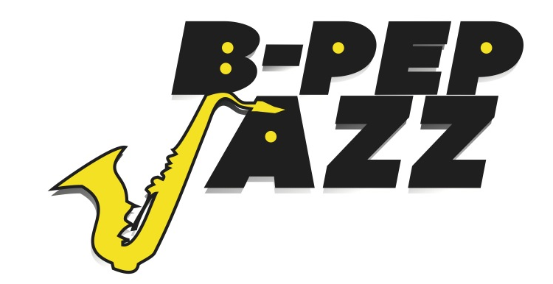

For additional information please call 412-758-7898 /412-361-2736
www.b-pep.net/www.b-pepjazz.org bpepjazz@gmail.com

Tim Stevens, B-PEP Chairman & CEO
B-PEP JAZZ Coordinator

B-PEP Jazz Host Committee Chair
Dr. KATHY S.WILSON HUMPHREY
President, Carlow University

B-PEP JAZZ Honorary Chair
JIM ROONEY
Author and Co-Partner, Rooney Consulting

